Detection Phenology Stages of Rice Crop in Thailand using Sentinel-1 Data

Porutai Thiantha¹, Panu Nuangjamnong², Sukij Skawsang³, Wisarut Khwansiridamrong⁴,
Tanachart Inpuron⁵ and Nontaphop Jindaphan⁶
Geo-informatics and Space Technology Development Agency
Bangkok, Thailand
Email: ¹porutai@gistda.or.th, ²panu.n@gistda.or.th, ³sukij@gistda.or.th, ⁴axcamo44@gmail.com, ⁵tanachart.inp@gistda.or.th and ⁶nontaphop@gistda.or.th

KEY WORDS: Phenology; Sentinel-1; Backscatter Values; Polarization Index.

ABSTRACT: Thailand is considered one of the leading countries in global rice exports. Therefore, it is essential to have comprehensive data coverage across the country for effective near-real-time management of both cultivation areas and accurate forecasting of harvest dates and crop yields. The detection of planting dates and growth stages is essential in order to forecast the harvest date accurately. However, there is a limit to applying satellite images to optical sensors based on frequent cloud cover in this region, particularly in the rainy season, which is mainly crop season. Then, this research utilized radar data to penetrate the cloud condition and solve the problem, either as a complement to optical data or used alone to monitor the growth phase of paddy. The study aims to investigate the growth of rice crops in Suphan Buri Province. We used backscatter values, including (1) Vertical-Vertical (VV), (2) Vertical-Horizontal (VH), (3) ratio polarization index (VV/VH), and (4) the polarization index (PI), at different growth stages. We also analyzed the appropriate threshold values derived from backscatter measurements for classifying each rice growth stage. The results demonstrate that the VH backscatter derived from Sentinel-1 satellite data can effectively classify different growth stages of rice crops, including (1) seeding, (2) tillering, and (3) flowering. The classification accuracy of seeding, tillering, and flowering is 91.05%, 59.59%, and 66.33%, respectively. In addition, the overall accuracy and Kappa coefficient of classification are 72% and 0.58, respectively. The result is acceptable and can be improved by adjusting the model in the next crop season experiment.

1. INTRODUCTION
In the Sustainable Development Goals (SDGs) for 2030 established by the United Nations, it is stated that food security and sustainable agriculture are directly related to global development and human livelihoods [1]. Thailand is considered one of the leading countries in global rice exports. Currently, Thailand cultivates rice both in the regular and off-seasons. However, rice cultivation practices vary across different regions of the country. Rice cultivation is a significant and highly popular agricultural activity, especially in the central regions of Thailand. According to statistics from 2018, Asia accounts for approximately 90.2% of global rice production, with Thailand ranking second (after India) in terms of rice production. Thailand's rice cultivation covers approximately 49.83% of the total cultivated area [2,3].
Thailand, located on the Indo-China peninsula in Asia, covers an approximate land area of about 513,000 square kilometers. The general temperature in Thailand ranges from 24°C to 30°C, and the average annual rainfall is around 1,000 millimeters. These conditions make Thailand highly suitable for rice cultivation, allowing for year-round rice farming. However, there are still challenges related to agricultural infrastructure and water resource management. The dispersed nature of rice cultivation across the country, coupled with limitations in agricultural infrastructure and water resources, necessitates the need for precise monitoring of rice farming activities. [4,5] Due to the diverse rice cultivation areas in Thailand, geospatial information technology, including remote sensing and satellite data, has become essential for monitoring and analyzing agricultural activities. This technology enables the efficient monitoring of crop growth, the assessment of environmental conditions, and the optimization of resource allocation.
Synthetic Aperture Radar (SAR)-based crop monitoring devices have been extensively utilized in this condition as an alternative due to their signals can get through clouds and poor lighting [6, 7]. Recent years have seen a significant increase in the use of SAR pictures by researchers for crop phenological monitoring [8, 9]. Recent mapping and monitoring of the rice fields has used high quality Sentinel-1 SAR imagery [10, 11]. A cloud platform might accelerate the pre-processing of Sentinel-1 SAR (time series analysis) for monitoring crops, which can be a time-consuming task. Whenever a considerable amount of Earth Observation (EO) data is available for analysis, the massive computational capability of the Google Earth Engine (GEE) cloud platform can be employed for monitoring and mapping crops over a greater region. With the use of the GEE platform, rice fields were mapped and tracked throughout Suphan buri Province.
This study utilizes Synthetic Aperture Radar (SAR) data from the Sentinel-1 satellite in single polarization and dual polarization modes to monitor and manage rice cultivation in different regions. The primary objective is to track the growth stages of rice, including the Seedling stage, Tillering stage, and Flowering stage. The study examines the behavior of microwave wave reflections in the C-band frequency range using the Google Earth Engine platform to analyze rice crop phenology. The analysis was conducted in 2022, covering 3,000 sample plots representing Suphan Buri province. This research serves as a valuable guideline for the development of comprehensive monitoring solutions at various levels of agricultural management. It aims to enhance the efficiency of these methods for application in other regions in the future.

2. MATERIALS AND METHODS
2.1 Study area
Suphan Buri province was chosen as the study area due to its suitability for investigating rice cultivation in the central region of Thailand. As shown in Figure 1, this area is located in the central part of Thailand and covers a total area of 5,358 square kilometers. It is a significant agricultural region with a predominant focus on rice cultivation, covering approximately 1,333 square kilometers. This region was selected as a representative area for studying rice crop growth because it serves as a central hub for rice cultivation in Thailand. Moreover, it exhibits diversity in rice variety selection, considering various aspects.
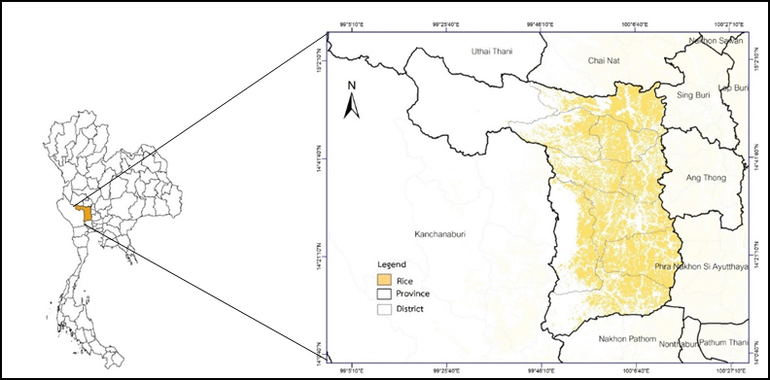
Figure 1. The study area for the rice paddy research encompasses Suphan Buri Province in central Thailand.

2.2 Data
2.2.1 The data used in this study consisted of Sentinel-1 satellite images at Level-1 Ground Range Detection (GRD). These images were acquired in the C-band wavelength range, with wavelengths ranging from 3.75 to 7.5 centimeters. The polarization modes used in this study were Vertical-Horizontal (VH) and Vertical-Vertical (VV). The imaging mode was interferometric wide. The study covered the entire study area and involved a total of 15 satellite images. The images were acquired at a 12-day interval, following the descending orbit of the satellite. The spatial resolution of the images was 10 meters. The specific acquisition dates of the Sentinel-1 images used in the study were as follows: 1) May 8, 2022 2) May 20, 2022 3) June 1, 2022 4) June 13, 2022 5) June 25, 2022 6) July 7, 2022 7) July 19, 2022 8) July 31, 2022 9) August 12, 2022 10) August 24, 2022 11) September 5, 2022 12) September 17, 2022 13) September 29, 2022 14) October 11, 2022 15) October 23, 2022. These Sentinel-1 images were crucial for the study's analysis of rice crop phenology and monitoring in the study area.

2.2.2 For the purpose of creating a model, 3,000 rice paddy fields were randomly selected. The selection criteria for these fields were as follows: Fields with an area greater than 1,600 square meters were chosen. This criterion was applied to reduce data variability during extraction. The selected fields were located within the irrigation zones and were registered in the central agricultural registry database maintained by the Department of Agricultural Promotion. These fields were specifically within the central region of Thailand. These fields were chosen based on their suitability for the study, and their information, including the start date of planting and the expected harvest date, was clearly defined in the database. This dataset was used for modelling and analysis in the study.

2.2.3 The growth stages of rice, as categorized by the Department of Rice, span from the initial planting to the harvesting period and are divided into the following phases: Seedling stage (0–25 days) Tillering stage (25–60 days old) Flowering stage (60–90 days old) and Harvesting stage (90–120 days old). These stages represent key developmental phases in the growth of rice plants and are essential for monitoring and managing rice crops effectively.

2.3 Methods
In this study, statistical methods were employed to analyze VV and VH data from Sentinel-1 satellite imagery for tracking and studying the growth stages of rice in each field. The analysis involved three crucial steps, as illustrated in Figure 2: 1) Pre-processing 2) Analysis of the Rice Phenology Profile and 3) Accuracy Assessment. These steps were integral to processing and interpreting the satellite data to monitor rice growth effectively.

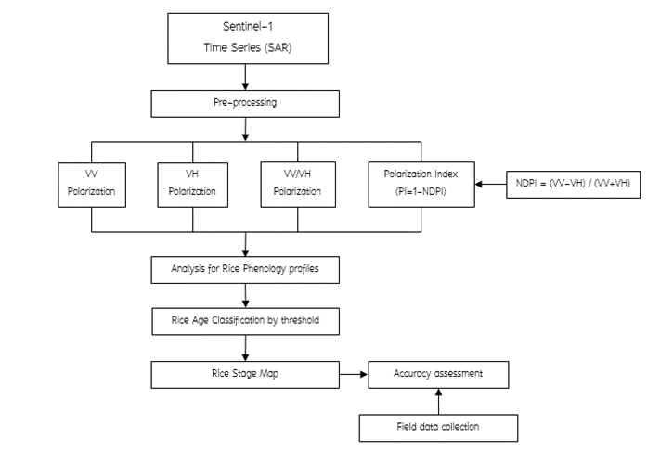
Figure 2. Flow of method.

2.3.1 The Sentinel-1 satellite imagery was pre-processed and corrected using the Google Earth Engine (GEE) Figure 3. cloud platform and the Sentinel-1 Toolbox. Multi-temporal speckle filtering was applied to extract the backscatter values for each time interval. This process was conducted for 3,000 rice fields selected rice fields that were simultaneously planted, covering the entire growth cycle from planting to harvesting. A total of 15 images were analyzed to track the growth stages of the rice crops.
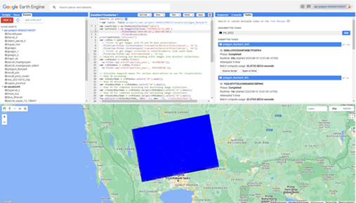

Figure 3. Deriving backscatter coefficients using Google Earth Engine

2.3.2 The analysis involves studying the relationship between the backscatter values of C-band radar on rice fields (areas > 1,600 square meters). The data is analyzed using the GEE platform, which provides information on two polarizations: VV and VH. Statistical analysis is performed, and Python's Scikit-learn library is used for further analysis. The data from different polarizations, including VV, VH, VV/VH, and Polarization Index (PI = 1-NDPI) where Normalize Difference Polarization Index (NDPI = (VV-VH)/(VV+VH)) is compared. This analysis aims to detect the growth stages of rice throughout the planting season.

2.3.3 Accuracy assessment involves evaluating the accuracy of data classification by comparing it with actual ground conditions. This evaluation is presented in the form of a confusion matrix, which helps analyze various indices and create a database of rice planting areas at different growth stages, including seedling, tillering, and flowering stages.

3. RESULTS AND DISCUSSION
Results of classifying rice growing areas with the Random Forest model by specifying a training sample of 3,000 plots using 15 Sentinel-1 satellite images The reflection coefficient of rice growing areas at each time period was obtained as shown in Figure 4, divided The test results are divided into 4 groups according to the polarization of the SAR data: VV, VH, VV/VH, and PI. The test results are as follows:

3.1 Analysis Polarization
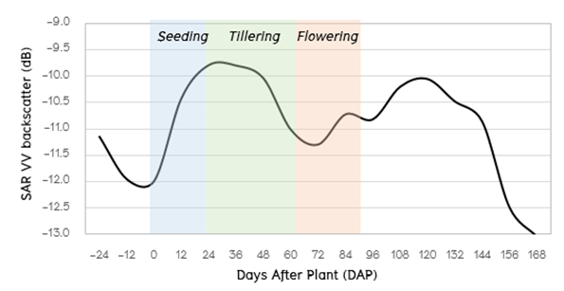
Polarization VV refers to transmitting and receiving signals in the vertical polarization direction, meaning signals are sent and received with the same orientation. However, VV polarization is not suitable for accurately monitoring rice growth. Figure 4. it is clear that VV polarization cannot provide a clear picture of rice growth. VV values tend to increase continuously during the rice's growth stages, from planting to the tillering stage. After that, when rice enters
Figure 4. VV Polarization backscattering
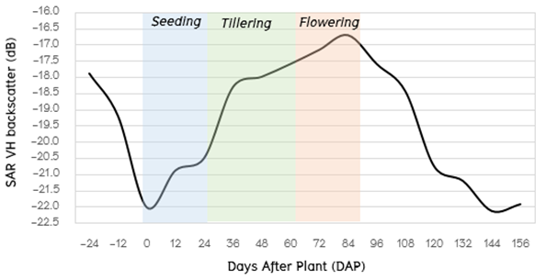
VH backscattering refers to the transmission of radar signals in the vertical polarization direction and their reception in the horizontal polarization direction. This dual polarization method provides valuable information for monitoring the growth of rice crops. Figure 5. During the seedling stage of rice growth, VH backscattering values are generally low. This is because rice plants are small, and radar signals have limited interaction with them. As rice plants grow and transition from the seedling stage to the tillering stage, VH backscattering values tend to increase. This increase is associated with the growth of rice plants and the enhanced interaction between radar signals and the developing vegetation. VH backscattering values typically reach their highest point during the flowering stage of rice. At this stage, rice plants are relatively tall and have a more pronounced impact on radar signals. This results in higher VH backscattering values. After the flowering stage, VH backscattering values gradually decrease. This decline occurs because rice plants have reached full maturity and have entered the reproductive and grain-filling stages. During this phase, rice plants tend to bend over, reducing their interaction with radar signals. In summary, VH polarization is crucial for tracking the growth stages of rice because it reflects the changing characteristics of rice plants as they progress from seedlings to maturity. This information is essential for monitoring crop health and estimating yield in rice cultivation.
Figure 5. VH Polarization backscattering

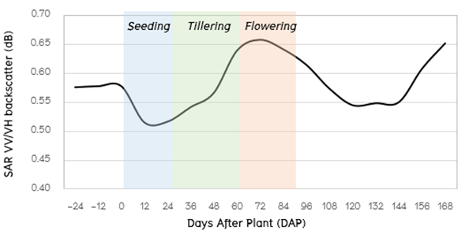
The ratio polarization index (VV/VH) can be effectively used to track the growth stages of rice. Start of Detectable Growth at Approximately 12 Days After Planting: The VV/VH ratio starts to show signs of rice growth around 12 days after planting, as seen in Figure 6. This initial increase is closely related to the early growth stages of rice seedlings. Following the initial change, the VV/VH ratio continues to increase significantly. This continuous increase is indicative of the progressive growth of rice plants in the fields.The VV/VH ratio typically reaches its highest value during the flowering stage of rice. At this point, rice plants are fully developed, and their interaction with radar signals is at its peak. This results in the highest VV/VH values. After the flowering stage, the VV/VH ratio begins to gradually decrease. This decrease is influenced by various factors, including the natural maturation of the rice plants and their transition into the reproductive and grain-filling stages. During this phase, rice plants may bend over, reducing their interaction with radar signals. As the rice crop approaches the harvest season, the VV/VH ratio continues to decline. This reduction is primarily due to the mature state of the rice plants, which have completed their growth cycle. In summary, the VV/VH ratio is a valuable tool for monitoring rice growth stages. It starts to reflect growth at around 12 days after planting, increases continuously as rice plants grow, reaches its peak during the flowering stage when rice plants are fully developed, and then gradually decreases as rice matures and approaches harvest.
Figure 6. VV/VH Polarization backscattering

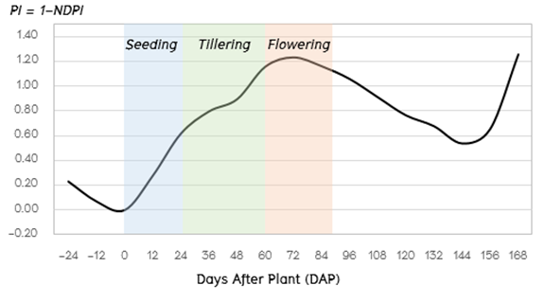
The Polarization Index (PI), calculated using the formula NDPI = (VV-VH)/(VV+VH), can be used to track the age of rice crops from planting to harvesting. Figure 7. Early Growth Stage: During this stage, when rice is just planted, the PI value is relatively low. This is because the rice plants are small, and their interaction with radar signals is limited. In this phase, rice is in the early stages of growth. Growth Continues: As the rice plants start to grow and transition from the early seedling stage to the tillering stage, the PI value gradually increases. This continuous increase indicates ongoing rice growth and progression through the growth stages. Radar signals reflect more significantly from the growing rice plants as they become denser. Flowering Stage: The PI value reaches its peak during the flowering stage of rice growth. At this point, rice plants are relatively tall and have a significant impact on radar signals. This is when radar signals reflect most strongly from the rice plants. Post-Flowering Stage: After the flowering stage, the PI value gradually starts to decrease. This decrease corresponds to rice plants being in their mature growth stages and undergoing structural changes. During this phase, rice plants tend to bend and change shape, leading to reduced interaction with radar signals. In summary, the PI, calculated using the NDPI, is a valuable indicator for tracking the age and growth stages of rice crops. It starts low when rice is just planted, increases as rice grows, peaks during the flowering stage, and then gradually decreases as rice matures and undergoes structural changes. The changes in PI reflect the evolving characteristics of rice plants as they progress from seedlings to mature crops.
Figure 7. VV/VH Polarization backscattering
The statistical analysis of Sentinel-1 SAR satellite data tracking rice growth from planting to harvest reveals that both VH backscattering and the Polarization Index (PI) are related to the growth stages of rice fields. Specifically, VH backscattering and PI increase in correlation with rice plant growth and the development of leaf structure in each growth stage. These values peak during the flowering stage, which corresponds to a period when rice plants are taller and exhibit increased leaf structure. This indicates that both VH backscattering and PI can be effectively used to detect the growth stages of rice.

3.2 Analyze the Polarization Values Corresponding to Rice Growth
Polarization values from remote sensing data, such as those obtained from radar imagery like Sentinel-1 SAR, can provide valuable information regarding rice growth. Here's an analysis of how polarization values correlate with rice growth stages:

3.2.1 VH backscattering in the backscatter imagery figure 8. exhibits changes that closely resemble the growth stages of the rice field. When the rice is in the seedling stage, VH backscattering is low due to the field preparation and the presence of water in the field, which reduces the backscatter and results in the lowest VH backscattering. As the rice plants age and progress through various growth stages, VH backscattering increases accordingly. It can be observed that during the tillering stage, VH backscattering is lower than -20.49. Then, during the heading stage, VH backscattering falls between -20.49 and -17.588. Finally, during the flowering stage, VH backscattering ranges from -17.5881 to -16.512. Beyond this, VH backscattering begins to decrease 90 days after planting. The primary reason for this decrease in VH backscattering in the later growth stages is that the rice plants tend to bend and lean over. This bending results in a reduction in the backscatter signal and is responsible for the observed decrease in VH backscattering.
In summary, the changes in VH backscattering in the backscatter imagery correspond closely to the growth stages of the rice field. VH backscattering is lowest during the seedling stage and gradually increases as the rice plants grow and develop, reaching its highest values during the tillering and flowering stages. After the flowering stage, VH backscattering starts to decline due to the bending of rice plants.

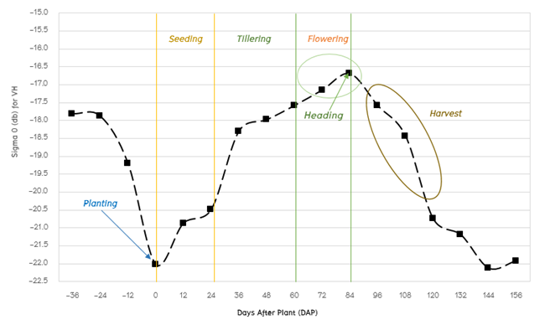
Figure 8. Phenological Stages of Rice for VH

3.2.2 The Polarization Index (PI), calculated as PI = 1-NDPI, follows a pattern similar to the growth and development of rice plants. Figure 9. Seedling Stage: When the rice plants are in the seedling stage, PI values are relatively low. This is because the fields are typically prepared, and water is introduced into the fields during this phase. PI values during this stage range from 0.097 to 0.646. Tillering Stage: As the rice plants continue to grow and enter the tillering stage, PI values increase. During this stage, PI values range from 0.647 to 1.081. The tillering stage is characterized by the development of multiple shoots from a single rice plant. Flowering Stage: PI values are highest during the flowering stage, ranging from 1.082 to 2.0. This stage corresponds to the full development of rice plants and the onset of flowering when they produce panicles. After Flowering: After the flowering stage, PI values start to decrease. This decrease is primarily due to the natural bending of rice plants as they mature and develop grains. This decline continues for approximately 90 days after planting.
The reason for this decreasing trend in PI values after flowering is mainly attributed to the bending of rice plants, which affects the backscattering of signals and leads to reduced reflection.
In summary, PI values derived from NDPI data exhibit a pattern that aligns with the growth and development of rice crops. This information can be used to track the various growth stages of rice, providing valuable insights for agricultural monitoring and management.
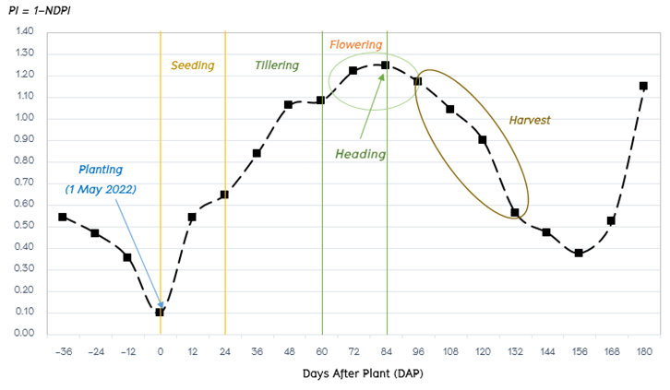
Figure 9. Phenological Stages of Rice for PI

The study results indicate that the backscatter values steadily increase from the beginning of rice cultivation until the rice reaches the flowering stage. After that point, there is a gradual decrease, primarily due to the bending of rice plants as they mature into the ripening stage. The minimum values for the VH polarization and PI are -22.018 and 0.097, respectively. In contrast, the maximum values for VH polarization and PI are -16.699 and 1.245, respectively. This shows that both VH polarization and PI exhibit a continuous upward trend in backscatter signal values from the initial planting stage and begin to decrease as the plants mature into the harvesting stage.

In summary, the polarization VH and PI trends show a continuous increase in backscatter signal values from the start of cultivation, reaching their highest values during the flowering stage, and then gradually decreasing as the rice crop matures into the harvesting stage. These trends are closely related to the growth and development stages of rice plants.

3.3 Relationship Between VH and PI Backscatter SAR Sentinel-1 and Paddy Age
The growth and developmental patterns of rice, from before planting until harvest, can be inferred from the reflectance values of the rice cultivation areas. These patterns are observed by locating the rice fields before planting and tracking them until harvest. Figures 10 and 11 depict the results of the reflection of both VH polarization and PI (Polarization Index).

Models for crop growth can be developed to identify the age stages of rice. This process should be continuous to enhance the efficiency of tracking rice growth from planting to harvest. It's not a one-time classification activity like categorizing types of rice cultivation in regular fields, such as using Landsat 8 in Vietnam [12] or Sentinel-1 in Western Java, Indonesia [13]. The classification method for analyzing rice cultivation in this manner requires continuous monitoring and coverage of the area, which can be achieved automatically.

Additionally, the reference reflection values used can be adjusted to cover various seasons. Determining the growth stages of rice becomes more straightforward and efficient when additional parameters related to rice growth are considered. Based on the correlation analysis of rice growth changes from the start of planting, both VH and PI values show significant correlations. VH has a higher correlation coefficient at 0.83, while PI has a correlation coefficient of 0.69.

In summary, VH and PI data, along with additional parameters, can be used to monitor and classify the growth stages of rice effectively and automatically, providing valuable insights for rice cultivation management.
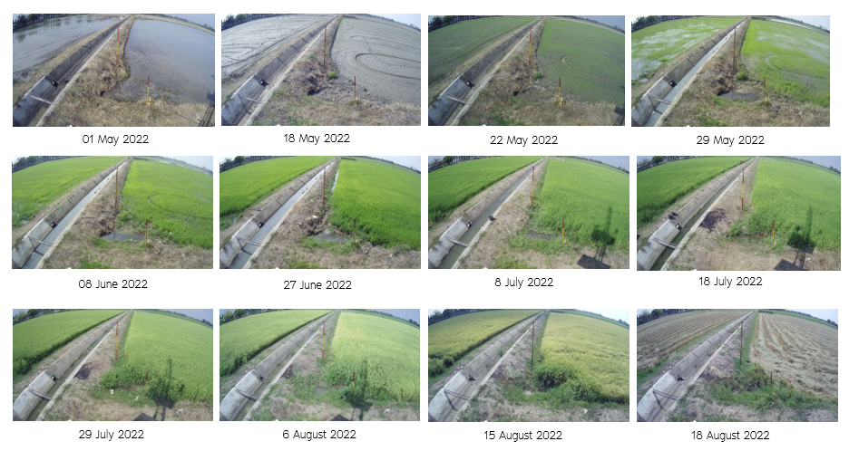
Figure 10. Rice field photographs

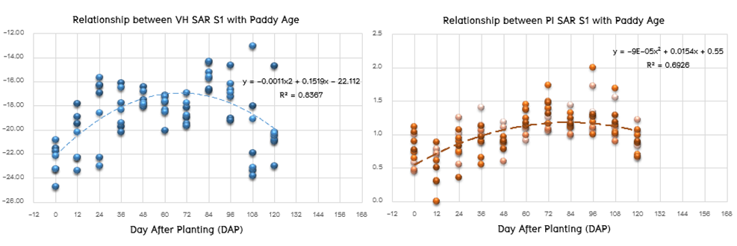
Figure 11. Correlation between Polarization VH and PI with Paddy age from Planting until Harvest

3.4 Accuracy assessment

The accuracy of rice growth stage classification from Sentinel-1 Polarization VH data compared to field surveys in Suphan Buri Province. The classification accuracies of seedling stage, tillering stage, and flowering stage are 91.05%, 59.59%, and 66.33%, respectively. The overall accuracy for all growth stages combined is 72%, and the Kappa Index is 0.586. Table 2.

Table 2. confusion matrix VH backscattering
VH SENTINEL-1 | Ground |  |  |  | Error (percentage) | User Accuracy  (percentage)
 | Seedling | Tillering | Flowering | Total
1. Seedling | 183 | 18 | 0 | 201 | 8.95 | 91.05
2. Tillering | 59 | 118 | 21 | 198 | 40.41 | 59.59
3. Flowering | 0 | 66 | 130 | 196 | 33.67 | 66.33
Total | 242 | 202 | 151 | 595 | Accuracy (percentage)= 72
Error (percentage) | 24.38 | 41.58 | 13.91

The accuracy assessment results for rice growth stage classification based on Sentinel-1 PI data compared to field surveys in Suphan Buri province. The classification accuracies of seedling stage, tillering stage, and flowering stage are 94.74%, 39.79%, and 62.38%, respectively. The overall accuracy for all growth stages combined is 72%, and the Kappa Index is 0.586. Table 3

Table 3. confusion matrix PI backscattering
VH SENTINEL-1 | Ground |  |  |  | Error (percentage) | User Accuracy  (percentage)
 | Seedling | Tillering | Flowering | Total
1. Seedling | 18 | 1 | 0 | 19 | 5.26 | 94.74
2. Tillering | 198 | 189 | 88 | 475 | 60.21 | 39.79
3. Flowering | 26 | 12 | 63 | 101 | 37.62 | 62.38
Total | 242 | 202 | 151 | 595 | Accuracy (percentage)= 45
Error (percentage) | 92.56 | 6.44 | 58.28

accuracy assessment of VH and PI values, it was found that VH had an overall accuracy of 72% and could classify rice growth stages in each stage with error rates of 24.39%, 41.58%, and 13.91% for the seedling, tillering, and flowering stages, respectively. PI values for each growth stage, it was observed that the classification for the seedling stage had a relatively high error rate of 92.56%. This is because PI, which calculates polarization for single polarization and dual polarization, cannot accurately capture rice growth stages during the early stages. Furthermore, in the flowering stage, the error rate for PI was 58.28%. This is due to the increasing plant density in the rice fields during this stage and variations in backscatter data, making it challenging to detect this stage accurately.

In summary, while VH provided reasonable accuracy in classifying rice growth stages, PI had limitations, particularly in the early and flowering stages, where the error rates were relatively high. The study aimed to determine the growth stages of rice fields in terms of seedling, tillering, and flowering stages by comparing them with reference points obtained from field surveys. The non-reference fields were compared to reference points, which served as representative locations for each growth stage. By mapping the averages for each field, we could accurately determine the growth stages of the rice. Figure 12.
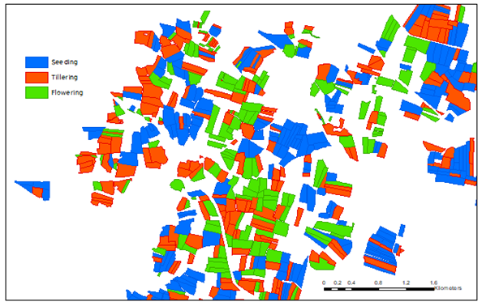
Figure 12. Rice paddy growth stage

4. CONCLUSION

Classification of rice growth stages using Sentinel-1 SAR data in rice fields in Suphanburi province can be achieved with high accuracy. Three distinct growth stages are distinguishable: seedling stage, tillering stage, and flowering stage, primarily by analyzing VH backscatter values. Seedling Stage: At the beginning of rice cultivation, during the seedling stage, VH values are relatively low. This is because the rice plants are small, and the radar signals have limited interaction with them. Tillering Stage: As the rice plants grow and transition from the seedling stage to the tillering stage, VH values increase. This increase in VH is related to the rice plants' growth. Generally, VH values reach their peak during the flowering stage. Flowering Stage: During the flowering stage, VH values typically reach their highest point. After this stage, as the rice plants enter the grain-filling stage, VH values gradually decrease. This decrease in VH is due to the rice plants beginning to bend, affecting their interaction with radar signals. and The accuracy of classifying rice growth stages using VH values compared to field survey data is approximately 75%, with a Kappa coefficient of 0.586.

5. REFERENCES

[1] Whitcraft, A. K., Becker-Reshef, I., Justice, C. O., Gifford, L., Kavvada, A., & Jarvis, I. (2019). No pixel left behind: Toward integrating Earth Observations for agriculture into the United Nations Sustainable Development Goals framework. Remote Sensing of Environment, 235, 111470.
[2] FAOSTAT Data. 2018. Available online: http://www.fao.org/faostat (accessed on 1 September 2020).
[3] World Food and Agriculture—Statistical Yearbook 2020; FAO: Rome, Italy, 2020.
[4] Gheewala, S. H., Silalertruksa, T., Nilsalab, P., Mungkung, R., Perret, S. R., & Chaiyawannakarn, N. (2014). Water footprint and impact of water consumption for food, feed, fuel crops production in Thailand. Water, 6(6), 1698-1718.
[5] Maraseni, T. N., Deo, R. C., Qu, J., Gentle, P., & Neupane, P. R. (2018). An international comparison of rice consumption behaviours and greenhouse gas emissions from rice production. Journal of Cleaner Production, 172, 2288-2300.
[6] Toan, T.L.; Ribbes, F.; Wang, L.F.; Floury, N.; Ding, K.H.; Kong, J.A.; Fujita, M.; Kurosu, T. Rice Crop Mapping and Monitoring Using ERS-1 Data Based on Experiment and Modeling Results. IEEE Transactions on Geoscience and Remote Sensing 1997, 35(1), 41–56, DOI: 10.1109/36.551933.
[7] Onojeghuo, A.O.; Blackburn, G.A.; Wang, Q.; Atkinson, P.M.; Kindred, D.; Miao, Y. Mapping paddy rice
fields by applying machine learning algorithms to multi-temporal Sentinel-1A and Landsat data, International Journal of Remote Sensing 2018, 39(4), 1042-1067, DOI: 10.1080/01431161.2017.1395969.
[8] Kuenzer, C.; Knauer, K. Remote Sensing of Rice Crop Areas. International Journal of Remote Sensing 2013, 34(6), 2101–2139, DOI: 10.1080/01431161.2012.738946.
[9] Mosleh, M.; Hassan, Q.; Chowdhury, E. Application of Remote Sensors in Mapping Rice Area and Forecasting Its Production: A Review. Sensors 2015, 15(1), 769–791, DOI: 10.3390/s150100769.
[10] Bazzi, H.; Baghdadi, N.; Hajj, M.E.; Zribi, M.; Minh, D.H.T.; Ndikumana, E.; Courault, D.; Belhouchette, H.
Mapping Paddy Rice Using Sentinel-1 SAR Time Series in Camargue, France. Remote Sensing 2019, 11, 887, DOI: 10.3390/rs11070887.
[11] Ndikumana, E.; Ho Tong Minh, D.; Baghdadi, N.; Courault, D.; Hossard, L. Deep Recurrent Neural Network for Agricultural Classification using multitemporal SAR Sentinel-1 for Camargue, France. Remote Sensing 2018, 10(8), 1217, DOI: 10.3390/rs10081217.
[12] Raviz J, Laborte A, Barbieri M, Mabalay M R, Gracia C, Bibar J E A, Mabalot P and Gonzaga H 2016 Mapping and Monitoring Paddy Areas in Central Luzon Philippines Using X and CBand SAR Imagery. Proceedings of Asian Association on Remote Sensing 2016.
[13] Chuc M D, Anh N H, Thuy N T, Hung B Q and Thanh N T N 2017 Paddy Paddy Mapping in Red River Delta Region Using Landsat 8 Images: Preliminary Results. IEEE The 9th International Conference on Knowledge and Systems Engineering, 209-214, DOI: 10.1109_kse.2017.8119460.

